Factors that cause TEC line jump points

Name: Zijun Liu

Course: COEN1550

Date: April 6th

Instructor: Beth Myers

**Context**

1. **Abstract** ………………………………………………………………………3
2. **Introduction** ……………………………………………………………….…4
3. **Research Object**……………………………………………………………....5
4. **Equation**…………………………………………………………………….....6
5. **Method**………………………………………………………………………....7
   1. **Plot Jump Point**………………………………………………………......7

**5.2.1. Auto Download and Auto Plot Jump Point**………………………......7

**5.2.2. How many Jump point**………………………………….…………......7

**5.3. Sky Plot by Azimuth and Elevation**………….…………........................8

**5.4. Regression on Machine Learning**………….…………............................8

**6. Analysis**………………………………………………………………………….9

1. **Appendix**
2. **Reference**
3. **Abstract**

At the 2019 Spring semester, I have a chance to work with graduate mentor to do the research project. I’m so excited about having a research chance. Research and Internship are the core for the applied science major students. Solving the real-world problem with the theoretical concept improves your skills and experience. I’m really excited about that. It’s a huge improvement for me to do the and it’s helpful for me to achieve master degree. In this research project, I’s so pleasured to have a chance with Brian Breitsch in SeNSe laboratory in GNSS field and we decide to work on Machine Learning through the Aerospace field about factors that cause TEC line jump points. As for why I work in this topic, because it’s basic for aerospace area and it can be used for Machine Learning to collect the data and analyze why it causes these jump points.

1. **Introduction**

Before we start the research, the graduate mentor and I discuss what I want to gain from joining this lab, we decide to learn Machine Learning. It’s a new computer science fields and widely applied in many fields. I’m a little nervous about what to do in the research. It’s hard to use the knowledge learned in the lecture into real world question. I’m willing to deal with real world question, because it gives me a big chance to use the theoretical concept in real-world problem. At the first two weeks, I learn the linear regression, logistic regression and some python library like Scikit. The Scikit is very useful library. It contains many fixed function that we can use to deal with some plot and analyze data problem. After that, we work on how to plot jump point by python in x-y coordinate. X is the time when it has jump points. Y is the TEC unit.

The TEC is total electron context. Total Electron Content means the number of electrons from the receiver to the satellite (1). Why we want to do this, because the global positional system is a wide applied tool and it investigates the earth’s ionosphere (1). It’s widely applied in many field like radio waves. That’s why we want to do.

1. **Research Objective**

My research topic is factors that cause TEC line jump point. We’re going to deal with the factors about why jump point occurred. Here is an example of TEC line jump point graph I did. This is on Sep 1ST, 2018 on G02 station. (*see Figure1*)

The orange jump point is the topic that we want to figure it out. In order to get the TEC line, we are going to difference between Pseudorange for L1 and L2. L1 and L2 means the dual frequency.

1. **Equation**

Here is the equation I used on this research to get the TEC line. All of these are related with Aerospace field. (*see Figure 2.1*)

This is equation to get the pseudorange by usng the frequency of dual frequency. (*see Figure 2.2*)

This is equation to get TEC line.

Based on observing a bunch of data. I check difference GPS station by different day. I have some basic guess about what it caused by. First, when the satellite reaches the skyline, it might happen with several scatter points. I guess the satellite arises or falls, there are many reasons that have impact on TEC line.

1. **Method**

For this research, it has four subsections.

**5.1. Plot Jump Point**

The first part is about plot the TEC line to check what might be reason to cause it. About how to plot it, I use the difference between dual frequency signal from satellite receiver and use the equation above to plot it. Here is the example of the plot (*see Figure 1*).

**5.2.1. Auto Download and Auto Plot Jump Point**

The second part is about auto download the data and plot the data. In this research project, I have to check many data to get some similarity. For example, I check the data from station G02 about 1 or 2 year’s data. If I plot the data by myself, it will waste so many time, so that’s why we work on how to auto download the data from the website to get the observation data and how to auto plot it. After that, I will auto save it in my laptop as picture. After that, I will check whole pictures to see the difference and similarity. Here is the example about how many data I save it as PNG picture (see Figure 6.2.1).

**5.2.2. How many Jump point**

The next step is that I have to check how many jump point occurring at each station in whole year. I have the same problem is that I have to check the data as much as I can, so how to auto calculate what I will work on it. I use threshold to compare with each data and export it as csv file. It’s very important for us, because we have to use these data to find out the Azimuth and elevation to make sky plot. Here is the example about how the table in .csv file like (see Figure 6.2.2).

**5.3. Sky Plot by Azimuth and Elevation**

In this step, I’m going to use the Azimuth and Elevation to get the sky plot. We get the Azimuth and Elevation for each station and export it in the .csv file too (see Figure 6.3).

This figure is for Satellite G01 on August 2017. We can see the jump point occur is Similarity on the different day, so we can use Regression in Machine Learning to summary some rule.

**5.4. Regression on Machine Learning**

I will explain more in the future.

1. **Analysis**

I will explain more in the future, because it’s not completed right now.

**Appendix**

Figure 1

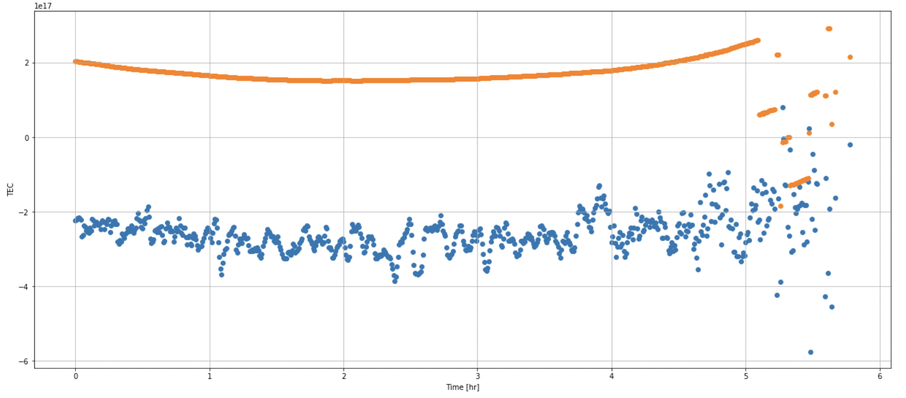

Figure 2.1



Figure 2.2

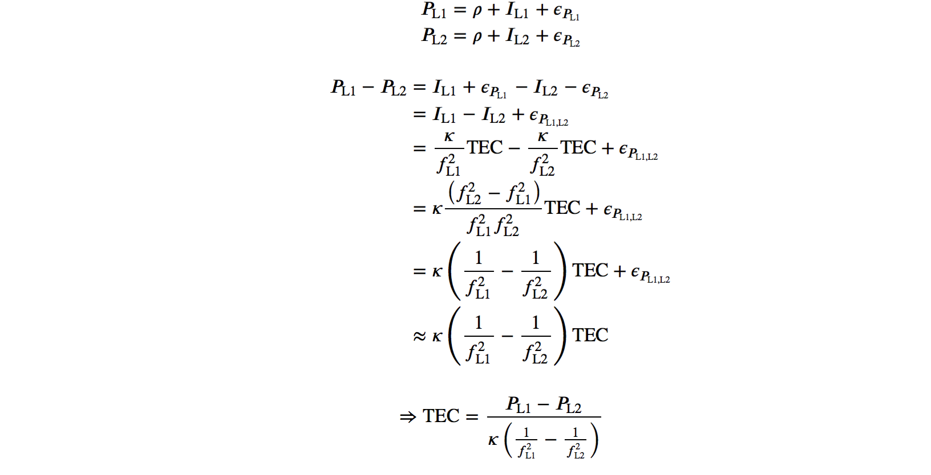

Figure 6.2.1

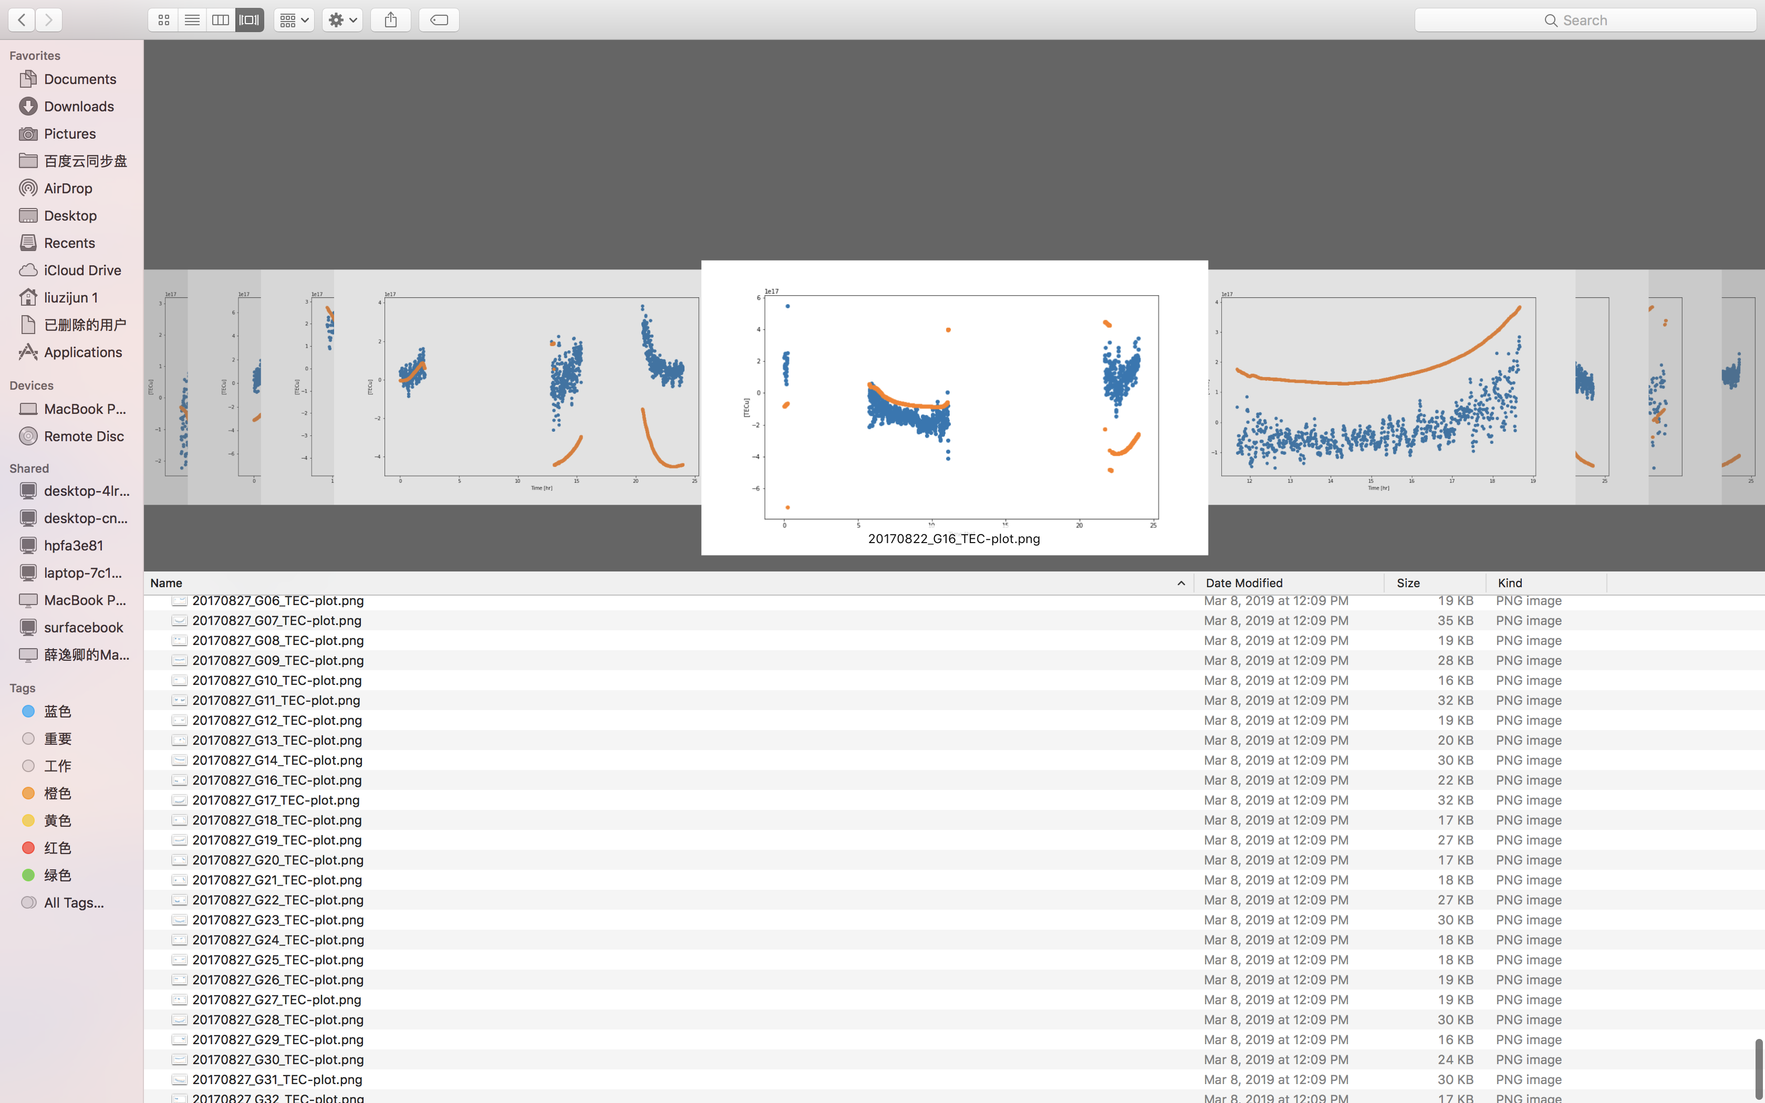

Figure 6.2.2

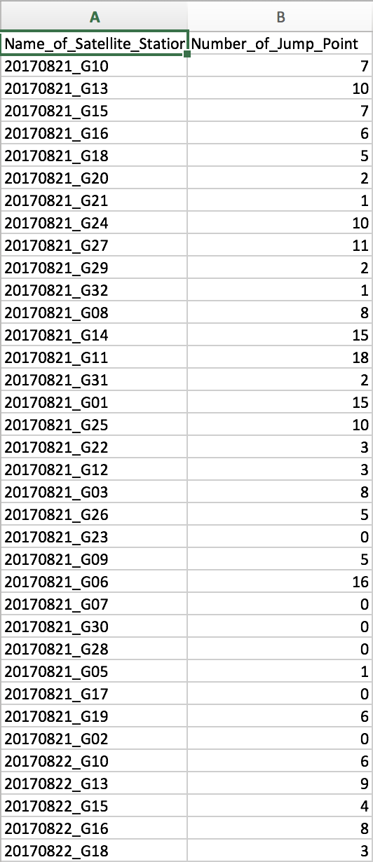

Figure 6.3

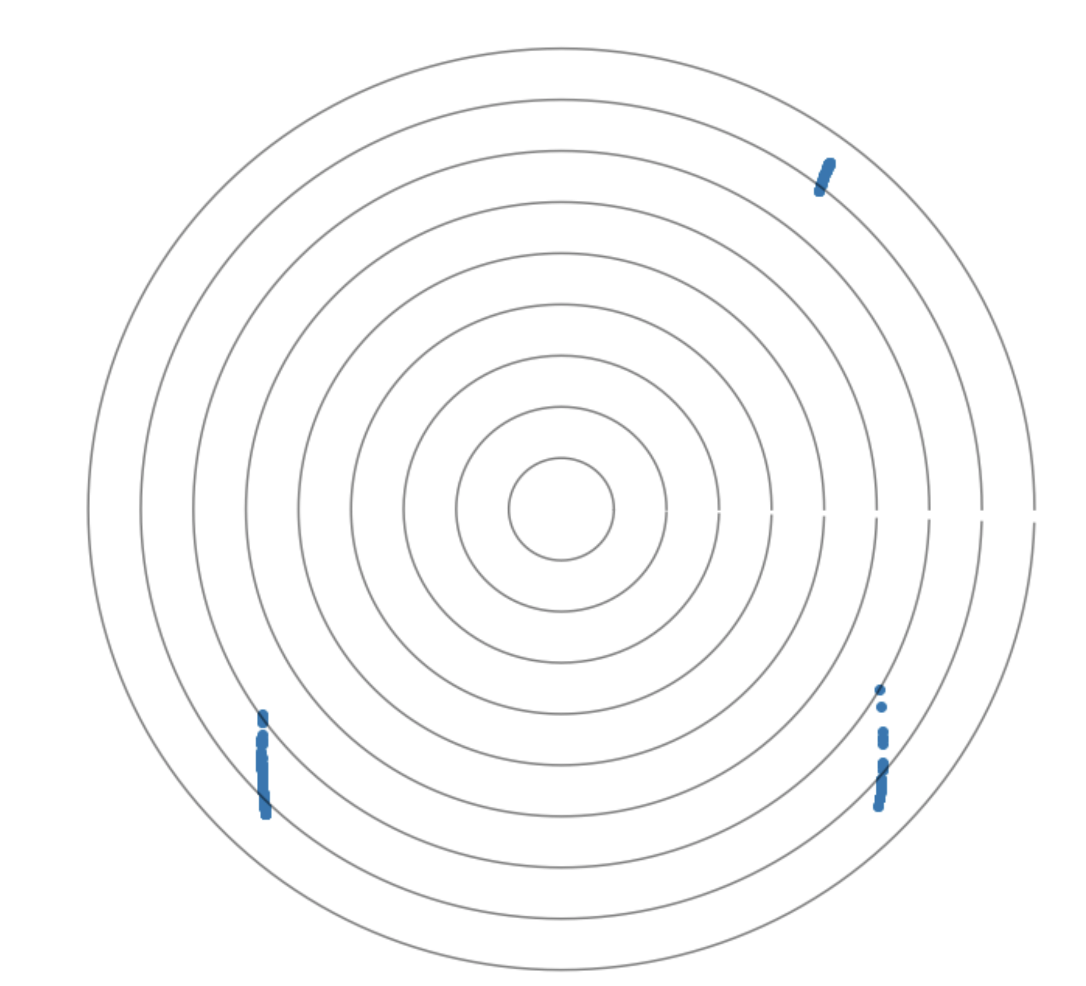

**Reference**

Mukesh, R., Soma, P., Karthikeyan, V., & Sindhu, P. (2019). Prediction of ionospheric vertical total electron content from GPS data using ordinary kriging-based surrogate model.*Astrophysics and Space Science, 364*(1), 1-21. doi:10.1007/s10509-019-3502-7

Ciraolo, L., Azpilicueta, F., Brunini, C., Meza, A., & Radicella, S. M. (2007). Calibration errors on experimental slant total electron content (TEC) determined with GPS. *Journal of Geodesy*, *81*(2), 111-120.

Misra, P., & Enge, P. (2006). Global Positioning System: signals, measurements and performance second edition. *Massachusetts: Ganga-Jamuna Press*.

Dow, J.M., Neilan, R. E., and Rizos, C., The International GNSS Service in a changing landscape of Global Navigation Satellite Systems, Journal of Geodesy (2009) 83:191–198, DOI: 10.1007/s00190-008-0300-3